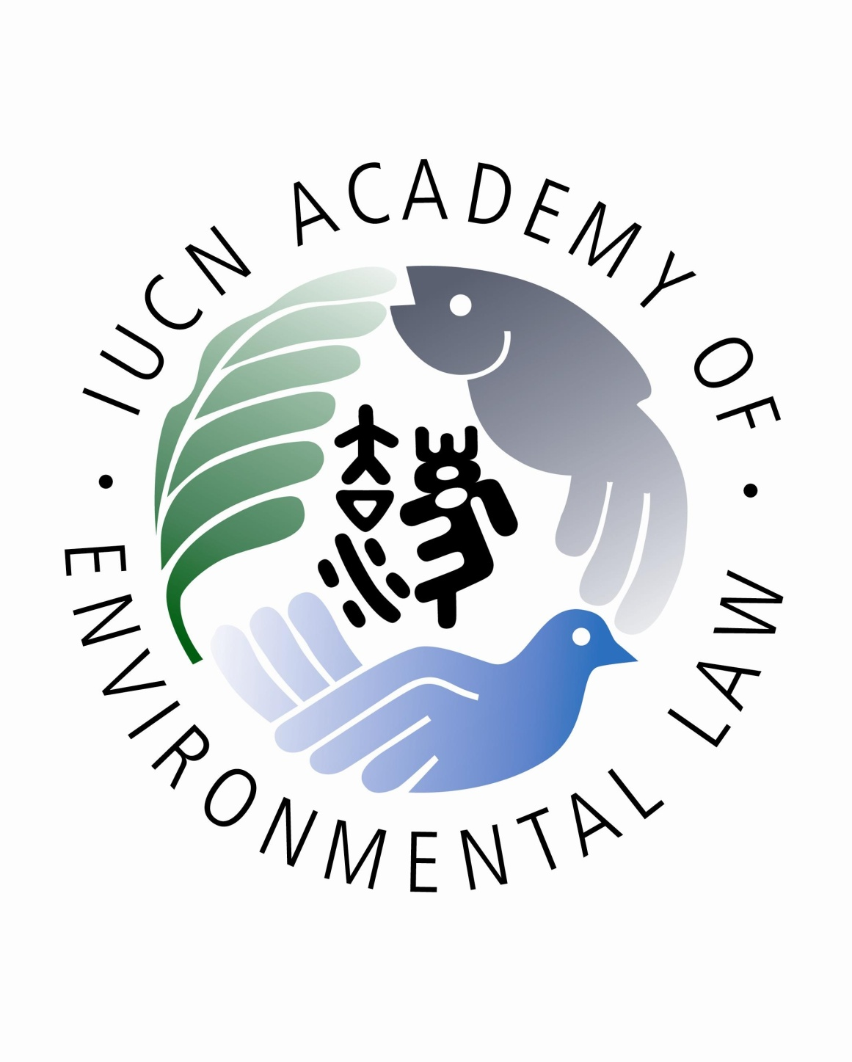

**PARTICIPANT FIELD TRIP INFORMED CONSENT,**

**ASSUMPTION OF RISK AND RELEASE FORM**

The Asian Development Bank (ADB) has approved a regional technical assistance project to strengthen environmental law in the Asia-Pacific region by developing environmental law champions through train-the-trainers programs (“TTT Programs”). ADB has selected law professors and lecturers from Thailand to participate in the in-country TTT Program to be held at Shangri-la Hotel Chiang Mai (“TTT Program #7”). The TTT Program #7 is being implemented by the IUCN Academy of Environmental Law and the University of Chiang Mai School of Law, in conjunction with ADB.

As part of the TTT #7 Program, ADB and IUCN Academy of Environmental Law will be conducting a field trip to Wiang Kumkam Heritage Site (the “Field Trip”) on 22 June, 2017 from 1:15 pm to 5:15 pm to demonstrate the field trip as a teaching methodology and learn about environmental policy and legal issues related to this important archaeological site located in the south east of Chiang Mai, Tha Wang Tan, Sarapee District, Chiang Mai.

This document sets out a description of the Field Trip and provides for certification of certain obligations and a release and waiver of liability against ADB and IUCN Academy of Environmental Law. Please read carefully before signing.

1. I will participate in the Field Trip based on the proposed itinerary below:

|  |  |  |
| --- | --- | --- |
| 1.15 – 1:45 | Field Trip Presentation:   * Distribution and explanation of information materials * Safety/security briefing * Briefing by guest speaker | Nuthamon Kongcharoen  Rob Fowler  Somchot Ongsakul |
| 1.45 – 2.15 | Travel to field trip site – Wiang Kumkam heritage site |  |
| 2.15 – 4.15 | Field trip inspection of Wiang Kumkam heritage site on two trolley buses |  |
| 4.15 -5.15 | Return on bus to hotel |  |
| 5.15 – 6.00 | De-briefing session (at training venue):   * discussion of field trip as a teaching methodology, including rationale, logistical considerations, safety issues, and function of the de-brief | All trainers |

2. I understand that my participation in the Field Trip specified above may involve certain risks or risk of injury. I am willing to assume and accept any such risks and agree that my safety is primarily dependent upon taking proper care of myself and exercising caution.

3. I understand that ADB, the IUCN Academy of Environmental Law and the Chiang Mai University School of Law do not represent or act as an agent for, and cannot control the acts or omissions of, the ferry operator, transportation carrier or other provider of goods or services involved in the Field Trip. I understand that ADB, the IUCN Academy of Environmental Law and the Chaing Mai University School of Law are not responsible for matters that are beyond its control.

4. ADB will provide safety and security briefing prior to the Field Trip and Chiang Mai University School of Law will provide a person trained in first aid to travel with the participants throughout the Field Trip. However, I recognize that I am responsible for my personal medical needs. There are no health-related reasons or problems which restrict my participation in this Field Trip.

5. I understand that accident/health/travel insurance is my responsibility and confirm that I am covered by health insurance to meet any and all needs or payment of medical costs while I participate in the Field Trip. I recognize that ADB, the IUCN Academy of Environmental Law and Chiang Mai University School of Law are not obligated to attend to any of my medical or medication needs, and I assume all risk and responsibility therefore. If I require medical treatment or hospital care during the Field Trip, ADB, the IUCN Academy of Environmental Law and Chiang Mai University School of Law are not responsible for the cost or quality of such treatment or care.

6. I agree to be responsible for securing my own travel insurance prior to the TTT Program #7.

7. In the event of medical emergency, I authorize ADB and IUCN Academy of Environmental Law to contact:

Name:

Relationship:

Phone:

Email:

8. I agree to observe any rules and practices that may be employed to minimize the risk of any injury and I agree to stop and seek assistance if I do not believe if I can safely continue with the Field Trip. I agree to limit my participation to reflect my personal fitness level.

9. I recognize that under the “Agreement Establishing the Asian Development Bank”, ADB enjoys immunity from most forms of legal process and all Governors, Directors, alternates, officers and employees of ADB, including experts performing mission for ADB, are immune from legal process with respect to acts performed by them in their official capacity, except when ADB waives the immunity. Nothing in this document will operate, or be construed, as a waiver, renunciation or any other modification of any privilege or immunity of ADB under the “Agreement Establishing the Asian Development Bank”.

10. Notwithstanding the above, I waive and release all claims against ADB, the IUCN Academy of Environmental Law, the Chiang Mai University School of Law and their employees or agents that are caused by my failure to comply with any rules, standards, and instructions related to the Field Trip.

Name: ______________________________________________

Signature: ___________________________________________

Date: _______________________