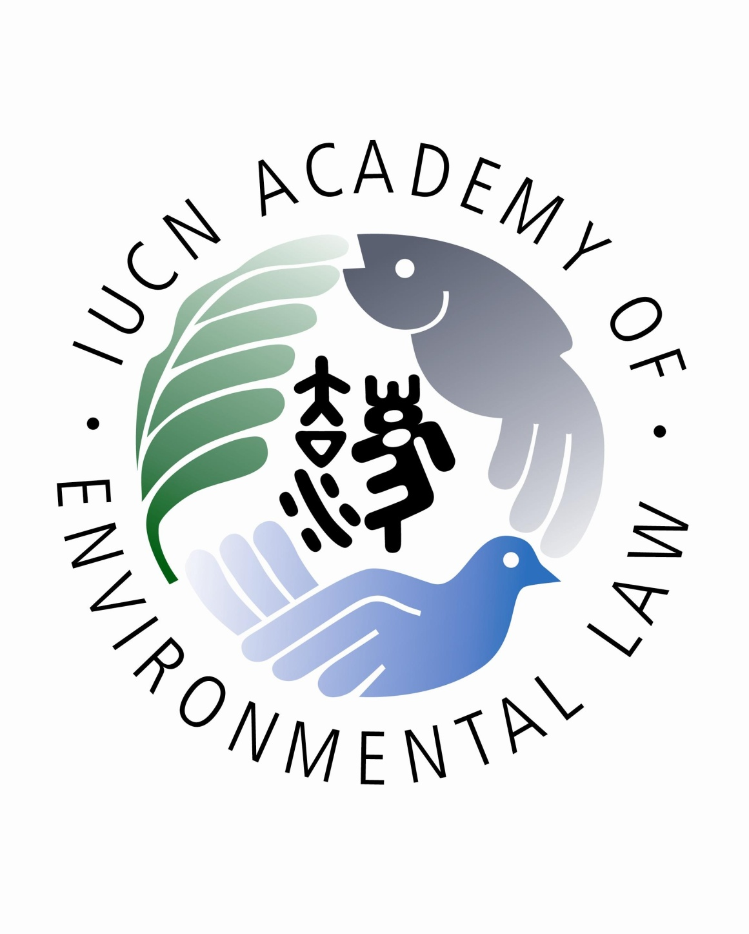

Photograph, Video and Audio Recording Consent Form
The Asian Development Bank (ADB) has approved a regional technical assistance project to strengthen environmental and climate change laws in Asia and the Pacific by conducting train-the-trainers programs (“TTT Programs”). ADB has selected law professors and lecturers from Sri Lanka and India to participate in the In-Country TTT Program to be held in Colombo, Sri Lanka (“TTT Program #10”) from 28th May – 1st June 2018. The TTT Program #10 is being implemented by the IUCN Academy of Environmental Law and the Open University of Sri Lanka, Department of Law, in conjunction with ADB.
The TTT Program #10 may be video-taped for the purposes of publication of a training video for further capacity building. Additionally, parts of the TTT Program #10 may be photographed or audio-recorded for capacity building and promotional purposes.
I, _________________________________________, do hereby consent, without any compensation, to the use by ADB and IUCN Academy of Environmental Law of my image, voice, or both, in the video recording, photograph or audio-recording described above.
In addition, I waive any right to inspect or approve the finished video, audio or photography.
I agree that all such pictures, video or audio recording and any reproduction thereof shall remain the property of ADB and IUCN Academy of Environmental Law and that the ADB and IUCN Academy of Law may use it as they see fit in connection with ADB’s regional technical assistance described above.
I understand that this consent is perpetual, that I may not revoke it, and that it is binding.
I understand that these images may appear publicly as part of ADB’s website and/or other promotional materials. Additionally, I agree to give permission to use by name, biography and other personal data in connection with any such uses of the photographs, video and audio recordings.
It is understood that this material will be used in a legitimate manner for the purposes of ADB’s regional technical assistance described above and is not intended to cause any harm or undue embarrassment to the parties involved.

Name: ______________________________________________

Signature: ___________________________________________

Date: ___________________

