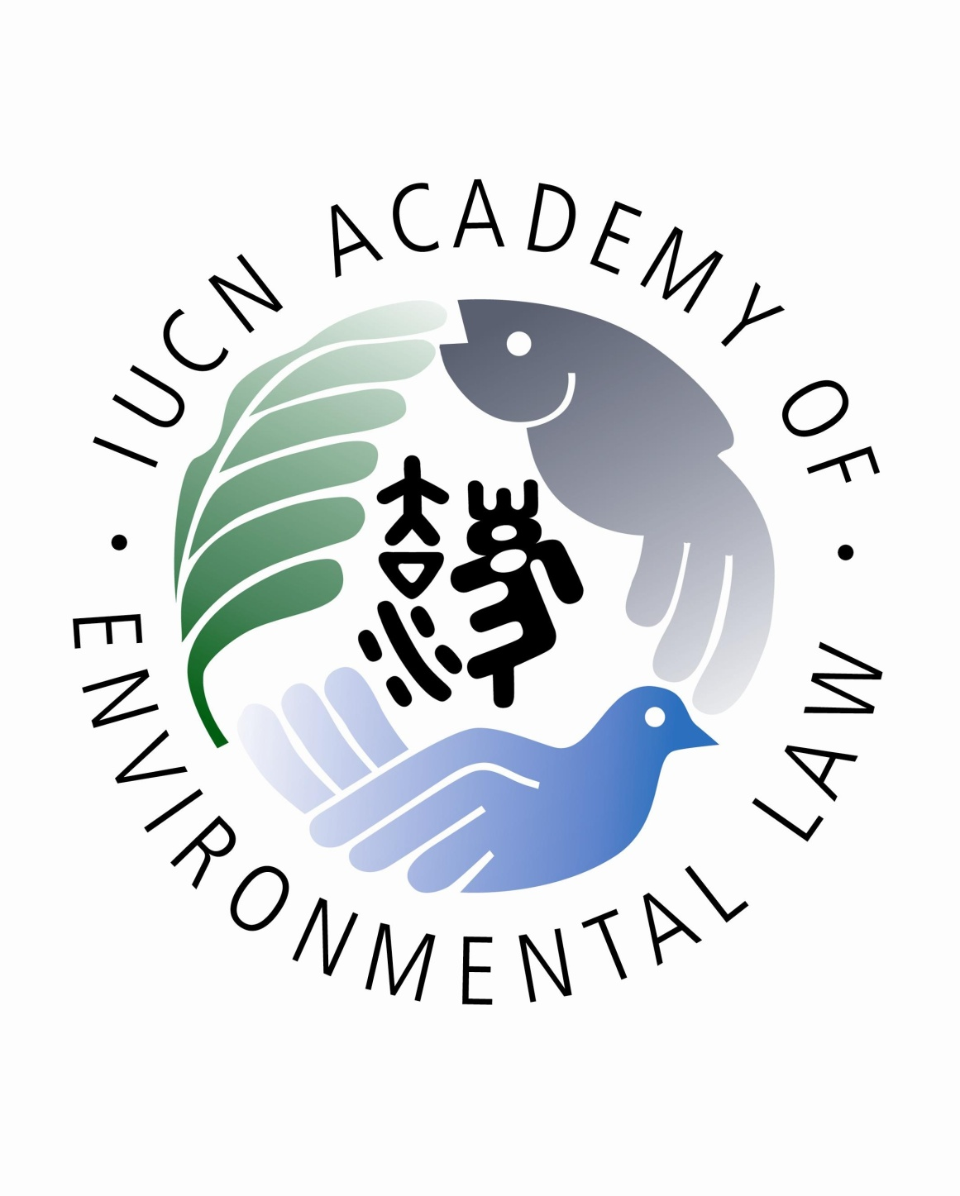
ADB Regional Capacity Development Technical Assistance
Strengthening Capacity for Environmental and Climate Change Laws in Asia and the Pacific

Train-the-Trainers Program
28th May – 1st June 2018
Colombo, Sri Lanka

PARTICIPANT FIELD TRIP INFORMED CONSENT,
ASSUMPTION OF RISK AND RELEASE FORM

The Asian Development Bank (ADB) has approved a regional technical assistance project to strengthen environmental and climate change laws in Asia and the Pacific by conducting train-the-trainers programs (“TTT Programs”). ADB has selected law professors and lecturers from Sri Lanka and India to participate in the in-country TTT Program to be held in Colombo, Sri lanka form 28th May – 1st june 2018. The TTT Program #10 is being implemented by the IUCN Academy of Environmental Law and the Open University of Sri lanka Department of Law, in conjunction with ADB.
As part of the TTT #10 Program, ADB and the IUCN Academy of Environmental Law will be conducting a field trip to the Bellanwilla-Attidiya Sanctuary in Colombo on 31st May 2018 from 1:30 pm to 5:15 pm to demonstrate the field trip as a teaching methodology and learn about environmental policy and legal issues related to protection of biodiversity.
This document sets out a description of the Field Trip and provides for certification of certain obligations and a release and waiver of liability against ADB, the IUCN Academy of Environmental Law and Open University of Sri Lanka Department of Law. Please read this form carefully before signing.
- I will participate in the Field Trip based on the proposed itinerary below:

15 &16 FIELD TRIP – BELLANWILA- ATTIDIYA SANCTUARY
1.30 – 1.45 | Field Trip Presentation:  - Safety/security briefing  - Distribution of field trip materials | Rob Fowler
1.45 – 2.45 | Travel by bus to field trip site
2.45 – 3.00 | First stop (Bellanwila Park and Walkway) - Briefing on flood mitigation efforts | Prof. Devaka Weerakoon, University of Colombo  Dr. Nalin Wikramanayake, Department of Civil Engineering, Open University of Sri lanka.
3.00 - 4.00 | Second stop - Walking tour of the Bellanwila wetlands
4.00 – 4.15 | Visit to wildlife rehabilitation centre
4.15 – 5.15 | De-briefing session (at Central Environmenal Authority Centre)  - Discussion of legal and policy issues arising  - discussion of field trip as a teaching methodology, including rationale, logistical considerations, safety issues, and function of the de-brief | All trainers
5.15 – 6.00 | Travel to dinner venue (OZO Hotel restaurant)
6.00 – 8.00 | Course Dinner

2. I understand that my participation in the Field Trip specified above may involve certain risks or risk of injury. I am willing to assume and accept any such risks and agree that my safety is primarily dependent upon taking proper care of myself and exercising caution.

3. I understand that ADB, the IUCN Academy of Environmental Law and the Open University of Sri Lanka Department of Law do not represent or act as an agent for, and cannot control the acts or omissions of, the transportation carrier or other providers of goods or services involved in the Field Trip. I understand that ADB, the IUCN Academy of Environmental Law and the Open University of Sri Lanka Department of Law are not responsible for matters that are beyond their control.

4. ADB will provide a safety and security briefing prior to the Field Trip and the Open University of Sri Lanka Department of Law will provide a person trained in first aid to travel with the participants throughout the Field Trip. However, I recognize that I am responsible for my own personal medical needs. There are no health-related reasons or problems which restrict my participation in this Field Trip.

5. I understand that accident/health/travel insurance is my responsibility and confirm that I am covered by health insurance to meet any and all needs or payment of medical costs while I participate in the Field Trip. I recognize that ADB, the IUCN Academy of Environmental Law and the Open University of Sri Lanka Department of Law are not obligated to attend to any of my medical or medication needs, and I assume all risk and responsibility therefore. If I require medical treatment or hospital care during the Field Trip, ADB, the IUCN Academy of Environmental Law and Open University of Sri Lanka Department of Law are not responsible for the cost or quality of such treatment or care.

6. I agree to be responsible for securing my own travel insurance prior to the TTT Program #10.

7. In the event of medical emergency, I authorize ADB and IUCN Academy of Environmental Law to contact:

Name:

Relationship:

Phone:

Email:

8. I agree to observe any rules and practices that may be employed to minimize the risk of any injury and I agree to stop and seek assistance if I do not believe if I can safely continue with the Field Trip. I agree to limit my participation to reflect my personal fitness level.

9. I recognize that under the “Agreement Establishing the Asian Development Bank”, ADB enjoys immunity from most forms of legal process and all Governors, Directors, alternates, officers and employees of ADB, including experts performing a mission for ADB, are immune from legal process with respect to acts performed by them in their official capacity, except when ADB waives the immunity. Nothing in this document will operate, or be construed, as a waiver, renunciation or any other modification of any privilege or immunity of ADB under the “Agreement Establishing the Asian Development Bank”.

10. Notwithstanding the above, I waive and release all claims against ADB, the IUCN Academy of Environmental Law, and the Open University of Sri Lanka Department of Law and their employees or agents that are caused by my failure to comply with any rules, standards, and instructions related to the Field Trip.

Name: ______________________________________________

Signature: ___________________________________________

Date: _______________________

